**Unit 9 Recitation Activities**

**9-1 Right Triangle Trigonometry**

**Trigonometry (Yoshiwara)**

**2.4 HW #1-6 (not right triangle, but still common sense- no calculation)**

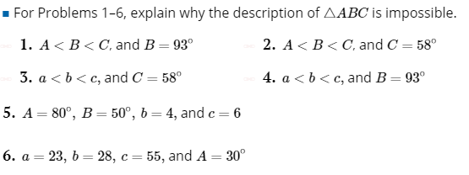

**2.4 HW #8**



**2.4 HW #17:**

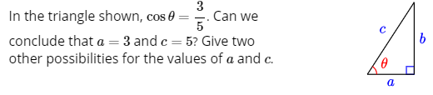

**2.2 Ex. 2.15 (without calculator)**

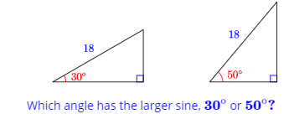

**2.2 Ex. 2.19**

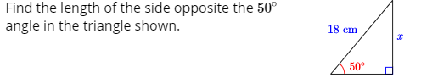

**2.2 Ex. 2.29**



**2.2 HW #1**

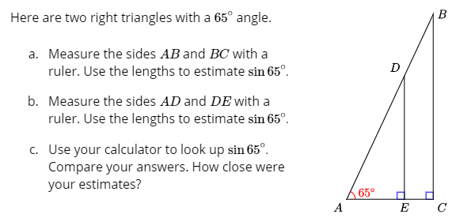

**2.2 HW #3**

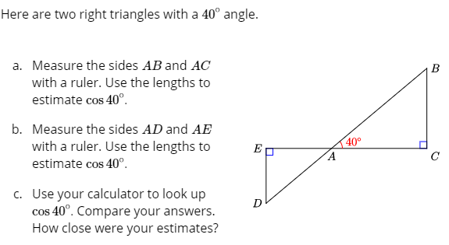

**2.2 HW #17-22**

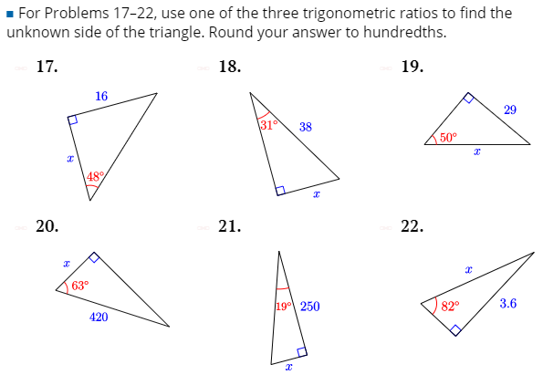

**2.2 HW #27-34**

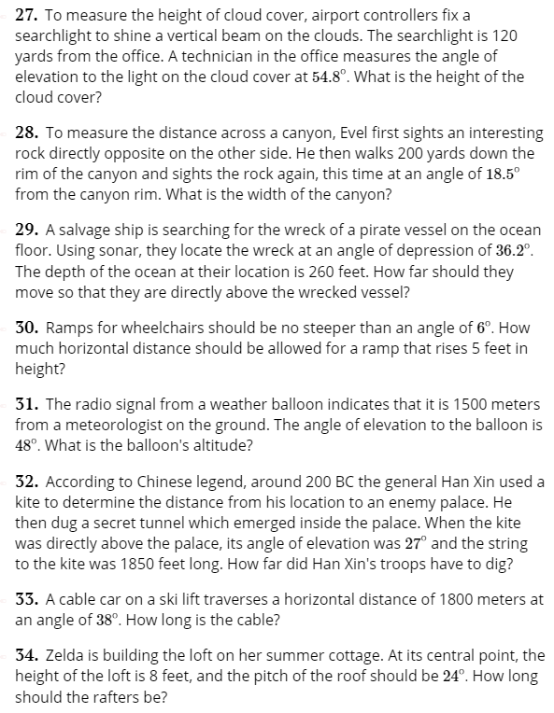

**2.2 HW #41-44**

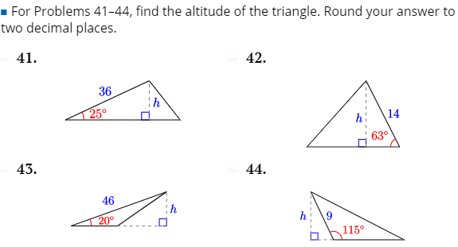

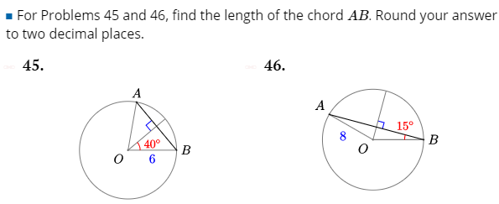

**2.2 HW #62:**

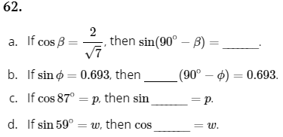

**2.2 HW #64:**

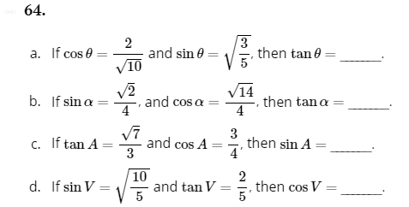

**2.2 HW #67**

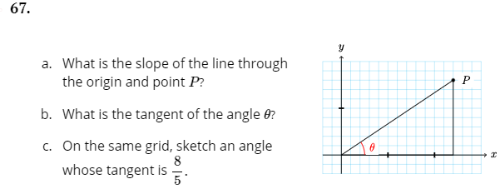

**FM 8.4:**

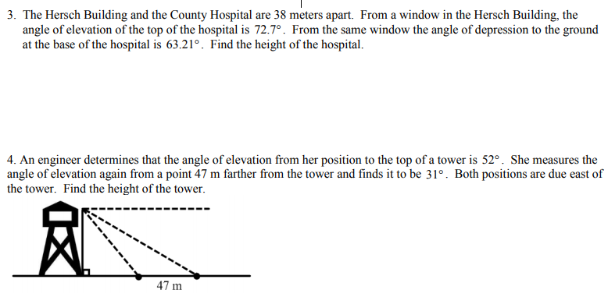

19. A rectangle is 14 cm wide and 48 cm long. Find the measure of the angles on either side of the diagonals. (inverse)

**APC 4.1 p. 215**

A person standing 50 feet away from a streetlight observes that they cast a shadow that is 14 feet long. If a ray of light from the streetlight to the tip of the person’s shadow forms an angle of 27.5 ◦ with the ground, how tall is the person and how tall is the streetlight? What other information about the situation can you determine?

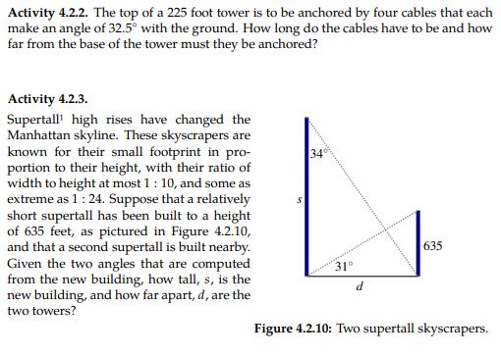



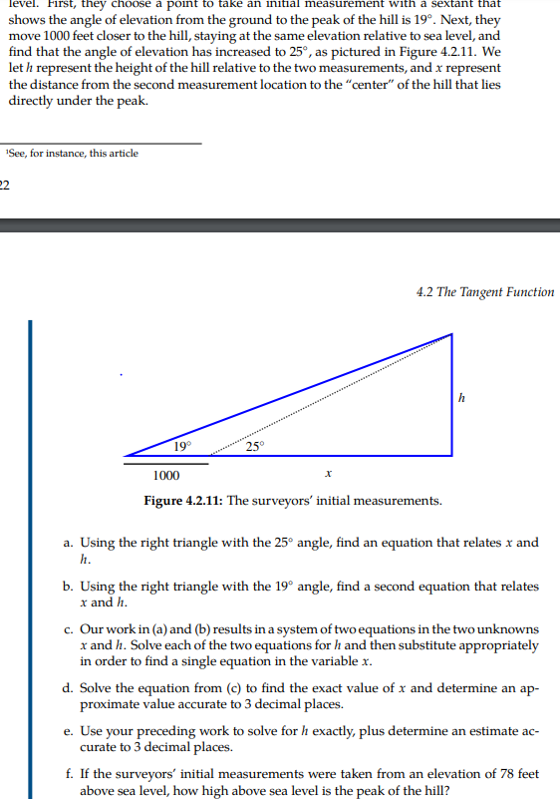

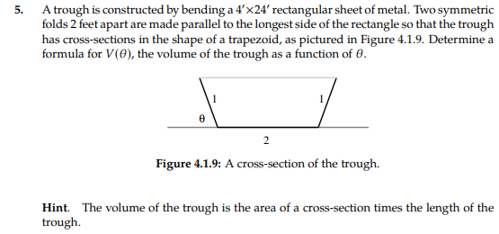

**Calc Medic: 4.1:**

1. Explain in words what the statement means.
2. If , find one set of possible values for *a*, *b*, and *c*.

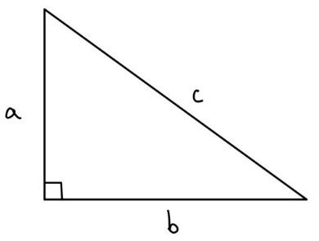

1. (Multiple Choice) Which of the following right triangles could demonstrate ?

**9-2 The Unit Circle**

**Yoshiwara Trigonometry**

**4.1 HW #25-30:**

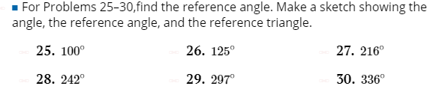

**4.1 HW #31-36 (Do with given radian measure as well):**

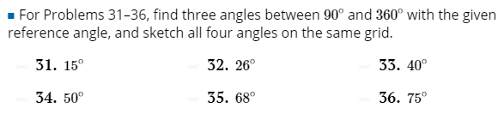

**4.1 HW #67-72:**

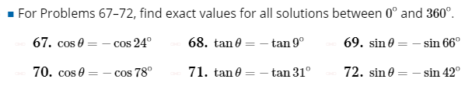

**4.1 HW #79-82:**

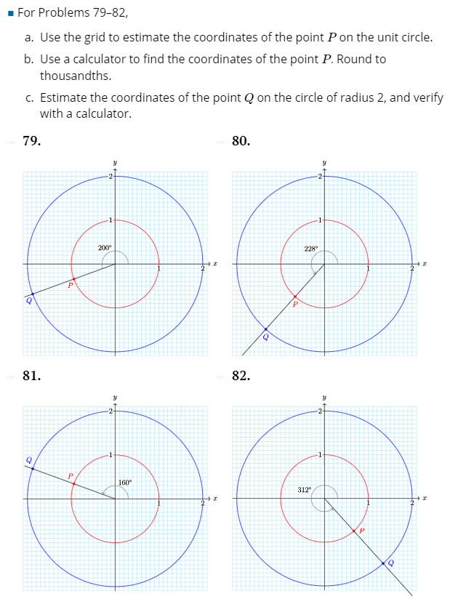

**4.2: 4.26:**

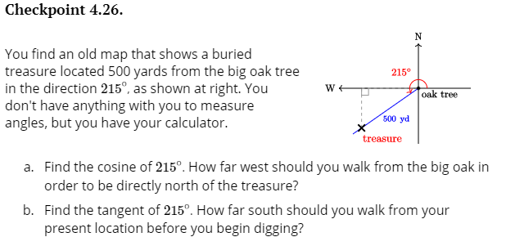

**6.1 6.6**



**6.1 6.9:**



**6.1 6.12**





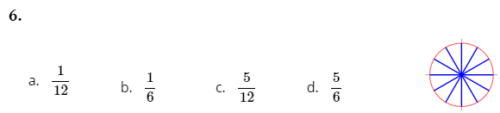

**6.2**

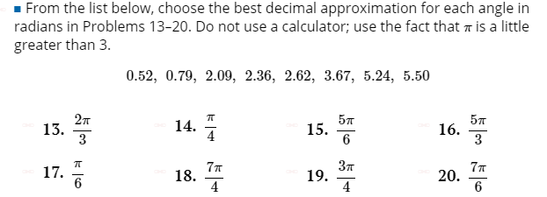

**6.2 HW# 40**

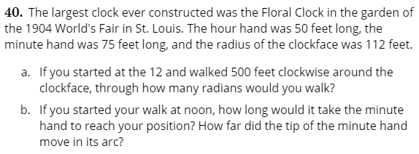

**6.2 HW #42-43:**

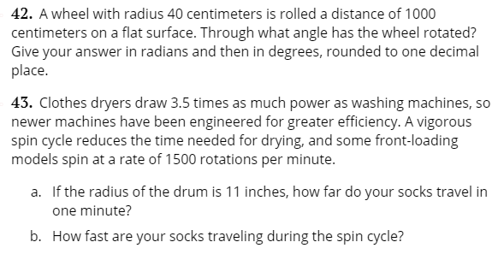

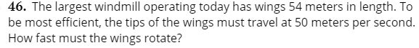

**6.2 Activity 6.2:**

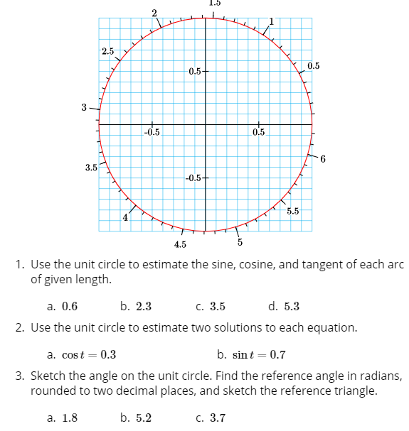

**6.2 HW #9-14**

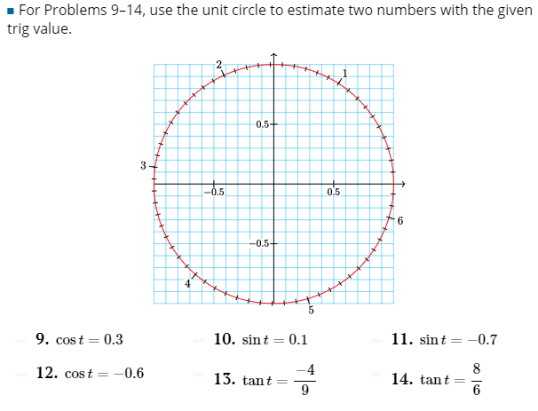

**6.2 HW#21-26**

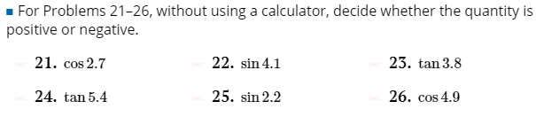

**6.2 HW #27-30:**

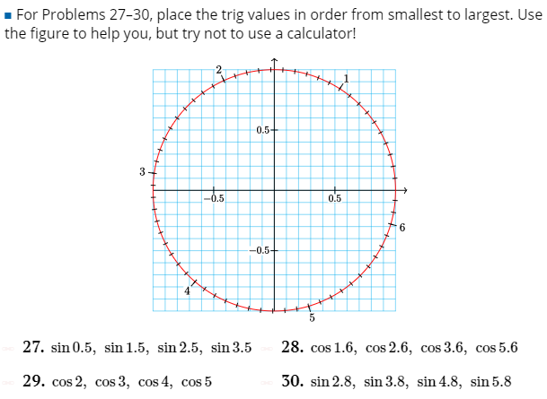

**6.2 HW#33-44**

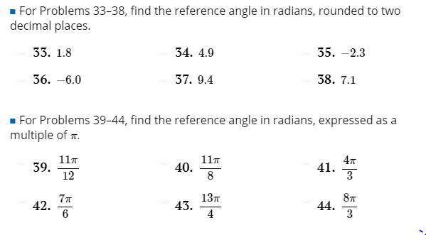

**6.2 HW #55-58**

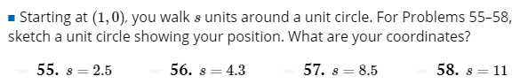

**6.2 HW #78-79**

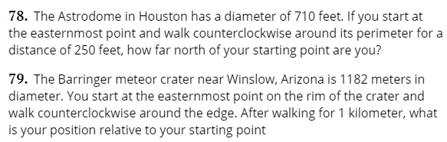

**Flipped Math**

**8.1:** 

**FM 8.1**

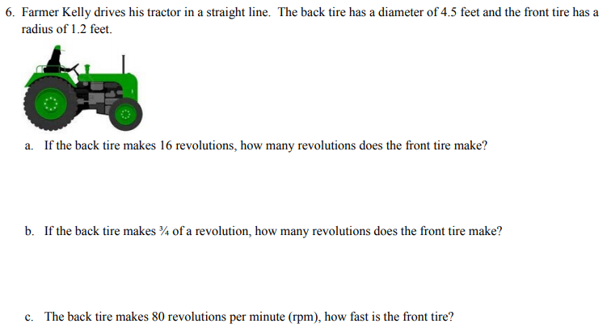

**FM 8.3**

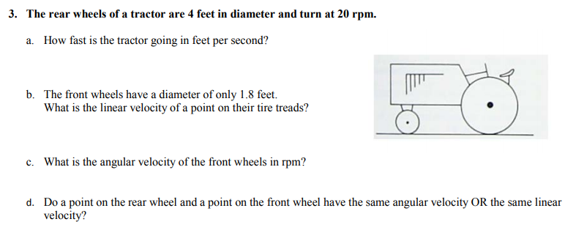

**FM 9.1**: Draw the reference triangle with hypotenuse ending at point (-5, 15). Then find all trig functions of the angle (with the hypotenuse being the terminal side) and of the reference angle.

**FM 9.1:** If tan θ = -8/15 and sin θ< 0, find the other trig functions of θ.

**S-Z 10.1 p. 710:**

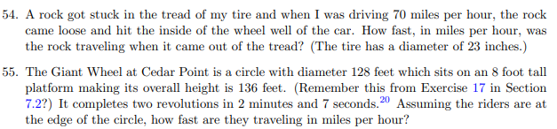

**S-Z**

**p. 736, 10.2**

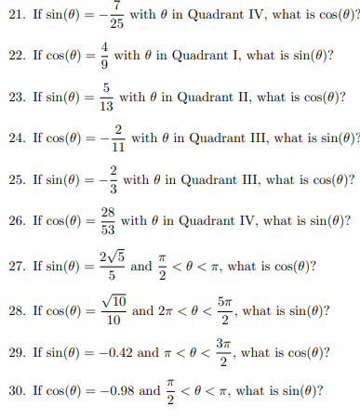

**p. 738:**

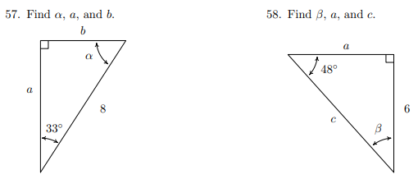

**p. 759: 10.3:**

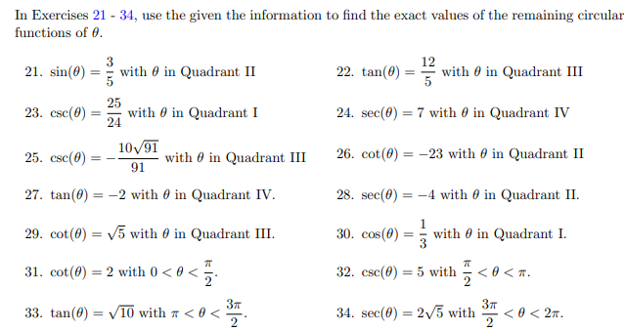

**APC 2.2:**

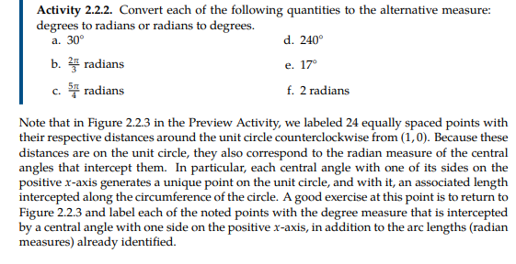

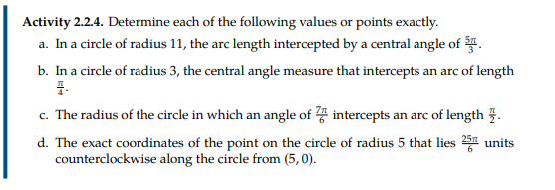

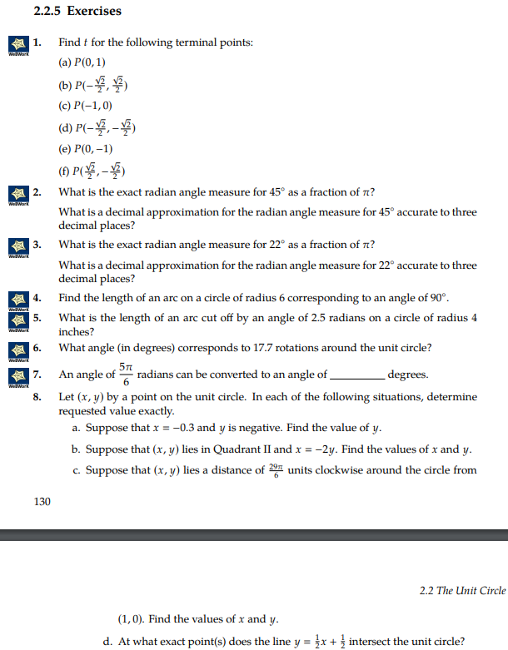

**Calc Medic 4.2:**

1. An ant is walking around the perimeter of a circular wreath with a radius of 8 inches. If the ant walked 21 inches, how many radians is the central angle that intercepts her path?

**Calc-Medic:**

**9-3 Trig Identities**

**MFG: 5.3**

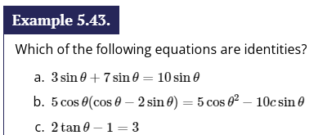

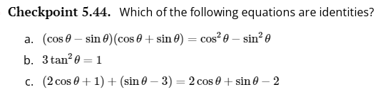

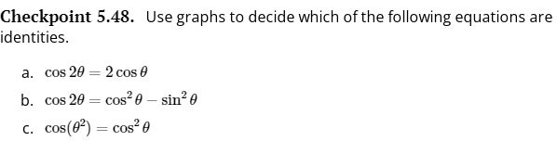

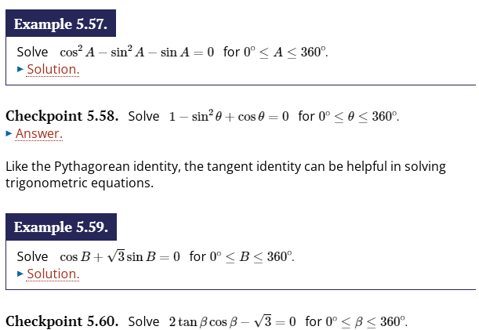

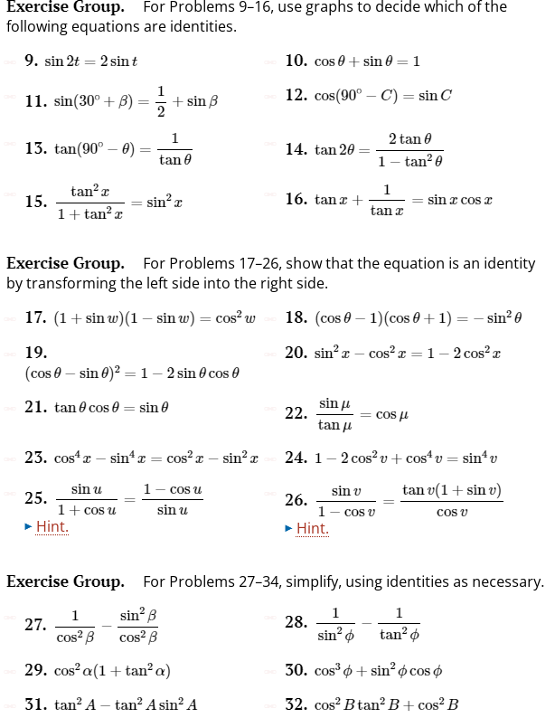

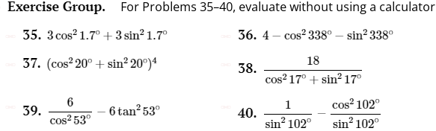

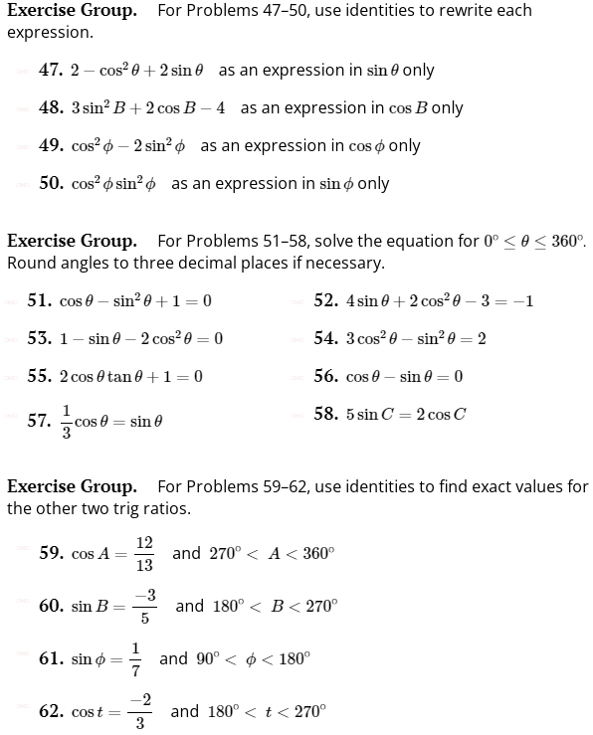

**(Note: More of the same in MFG 5.4)**

**FM 11.1**

**Verify Identity:**

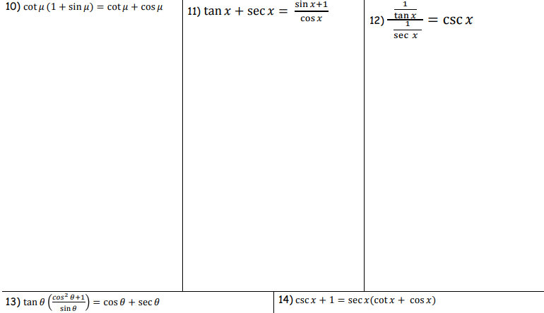

**FM 11.2**

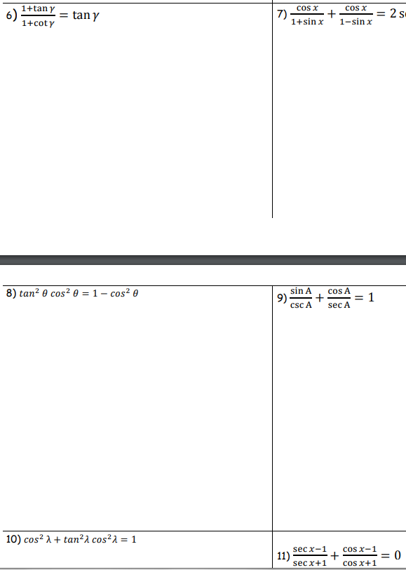

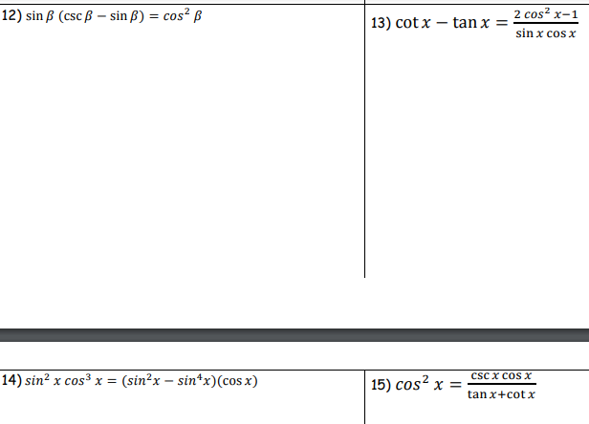

**FM 11.3:**

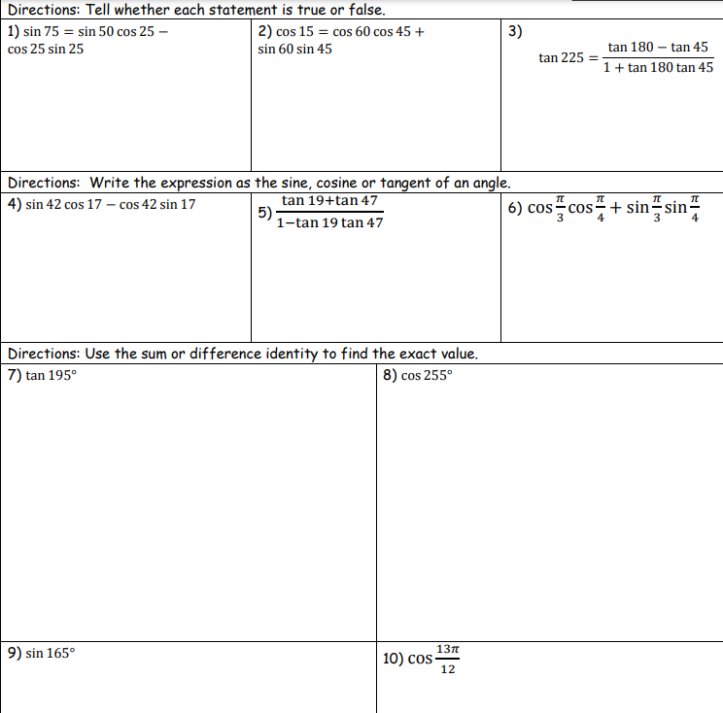

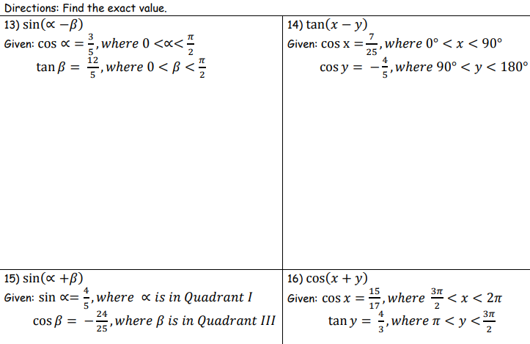



**FM 11.4**

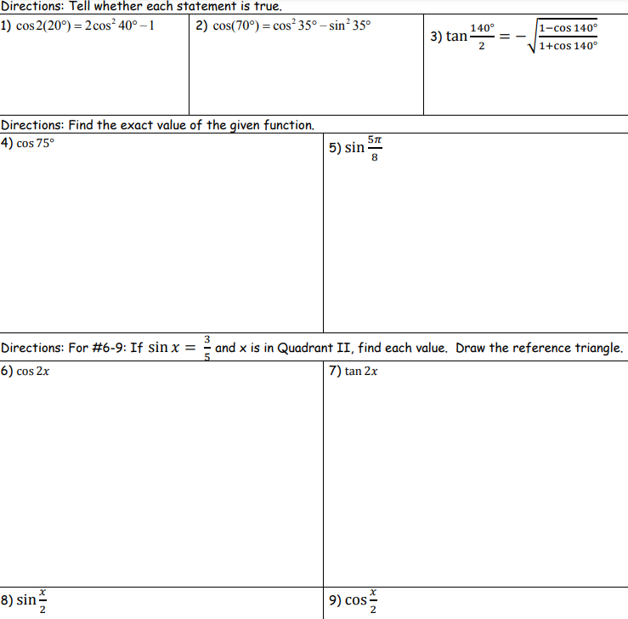

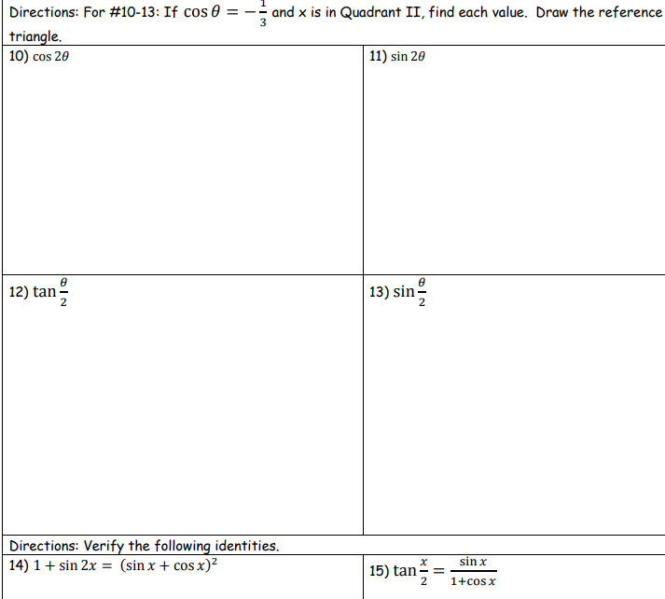

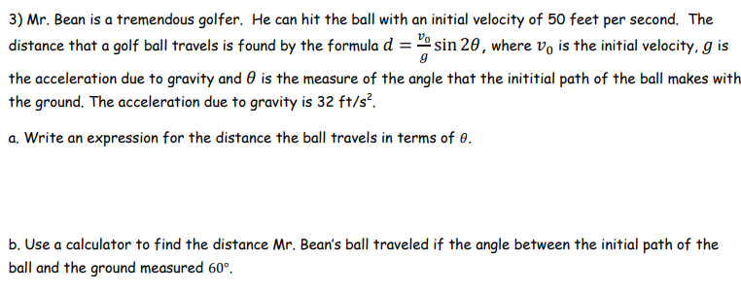

**S-Z 10.4**

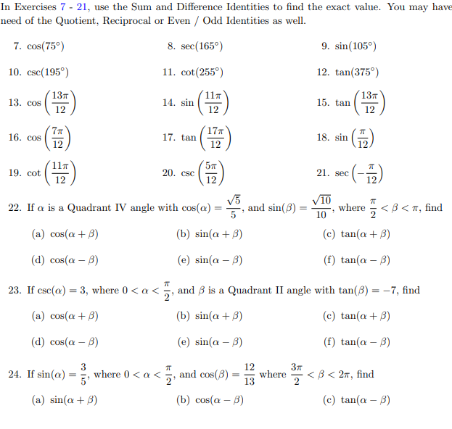

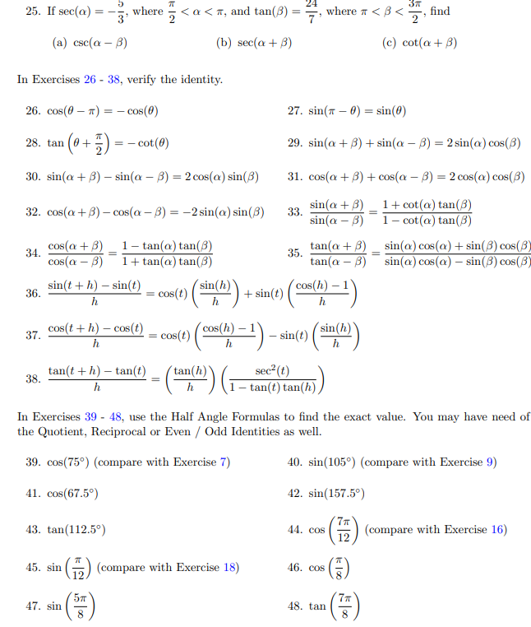

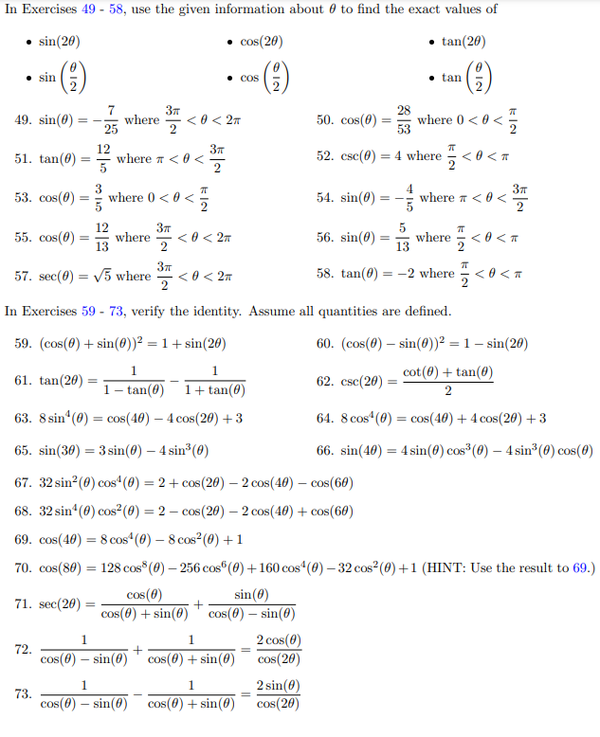

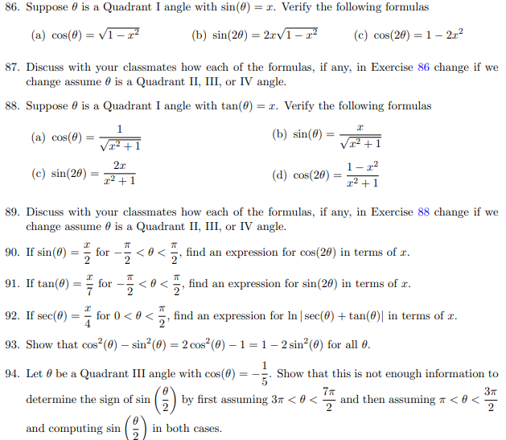

**ALSO (from old 10-1 Search: Probably a lot of overlap from above):**

**10-1 Trig Identities**

**Yoshiwara: 5.3**

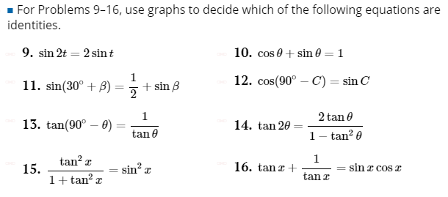

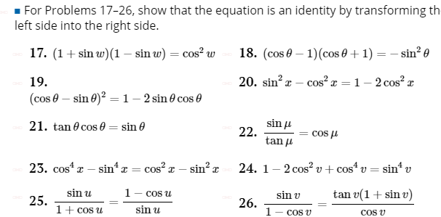

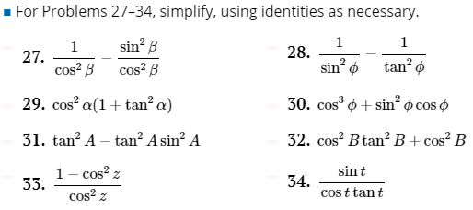

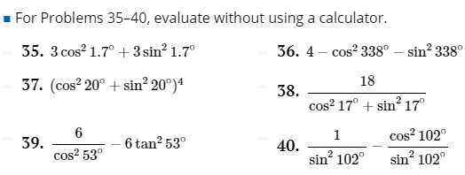

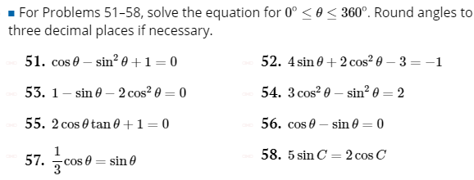

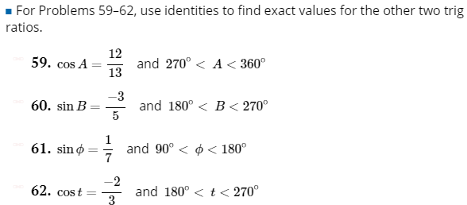

**8.1**

**HW**

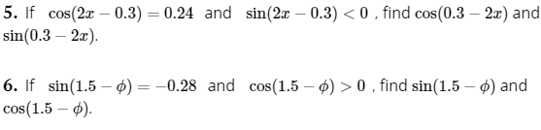

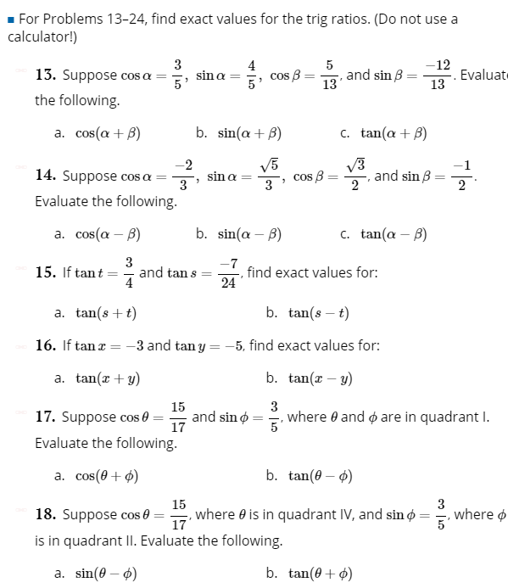

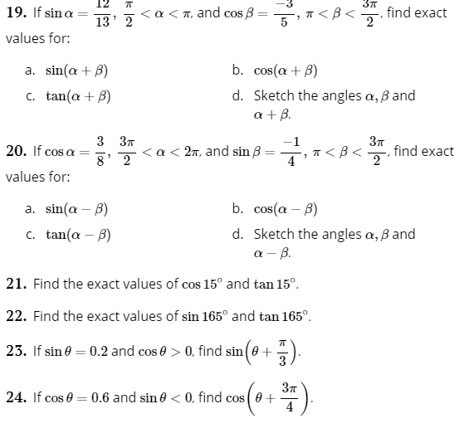

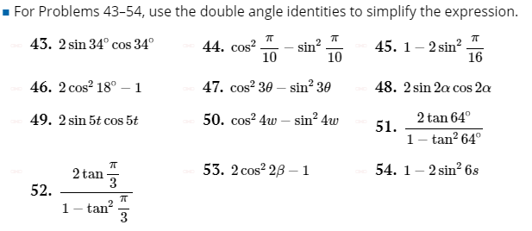

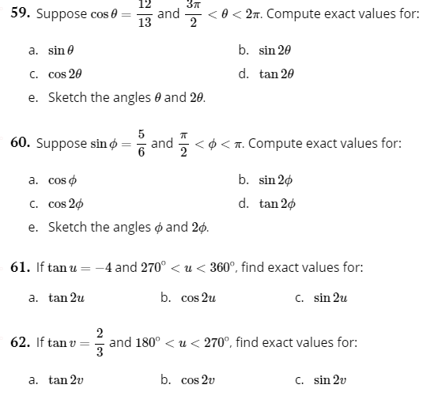

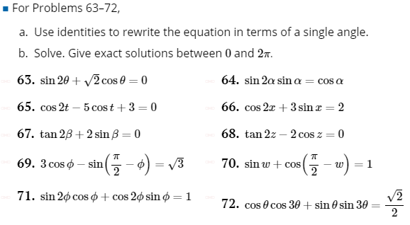

**S-Z**

**10.4 p. 782**

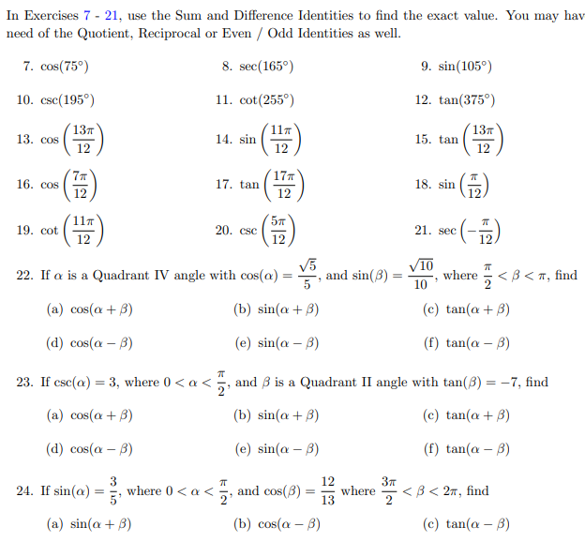

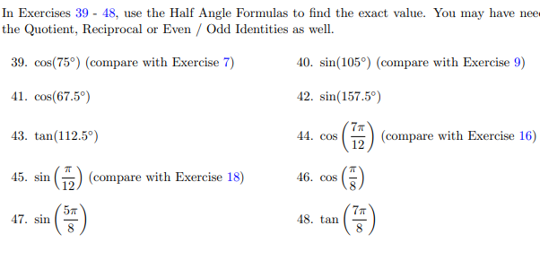

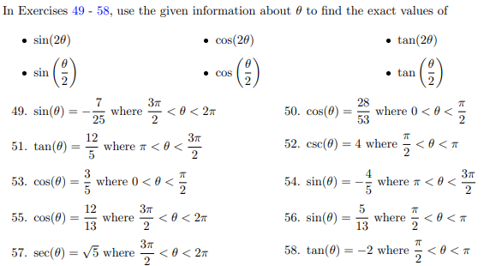

**p. 787**

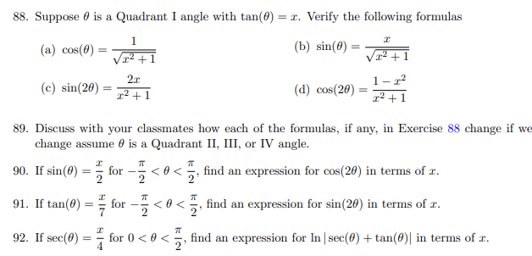

**FM:**

**11.4:**

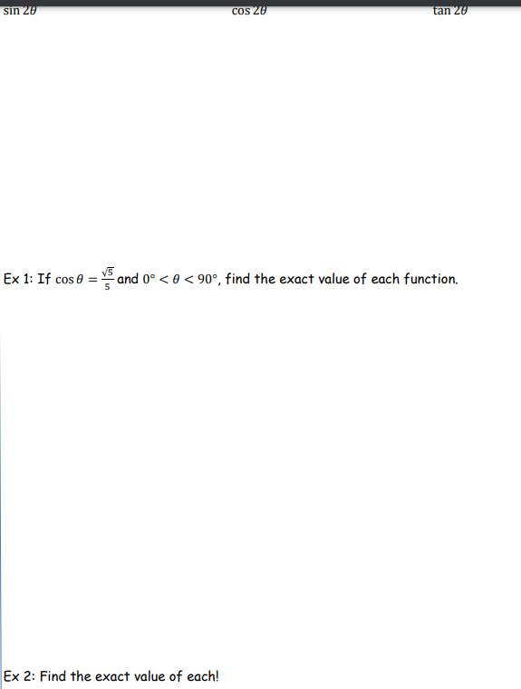

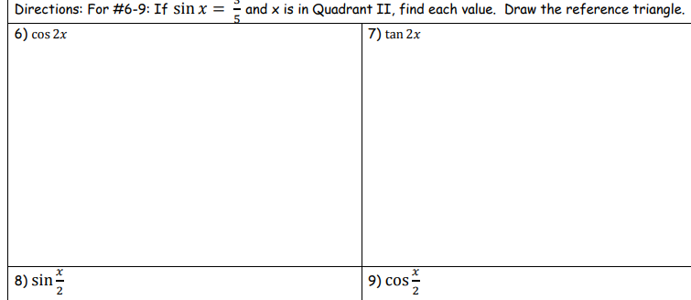

**(and more like it)**